**Battle Color Detachment Branding Guide**

* A description of each logo associated with the detachment is as follows:

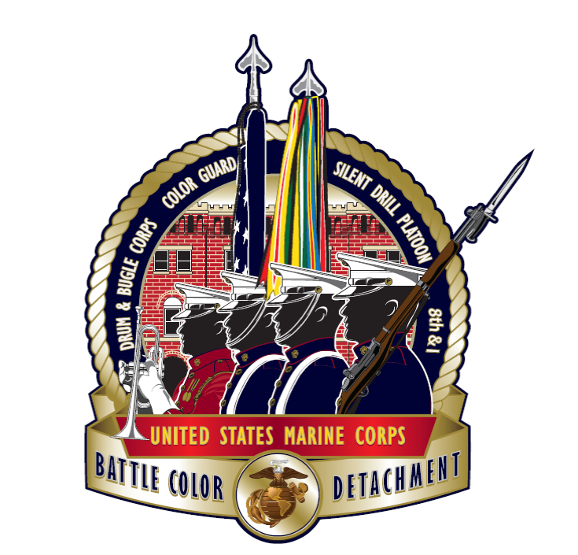

**Official Battle Color Detachment Logo**

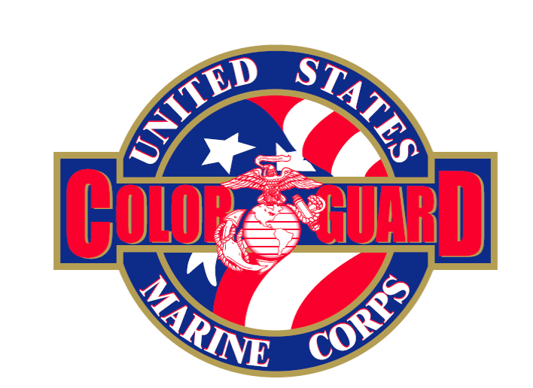 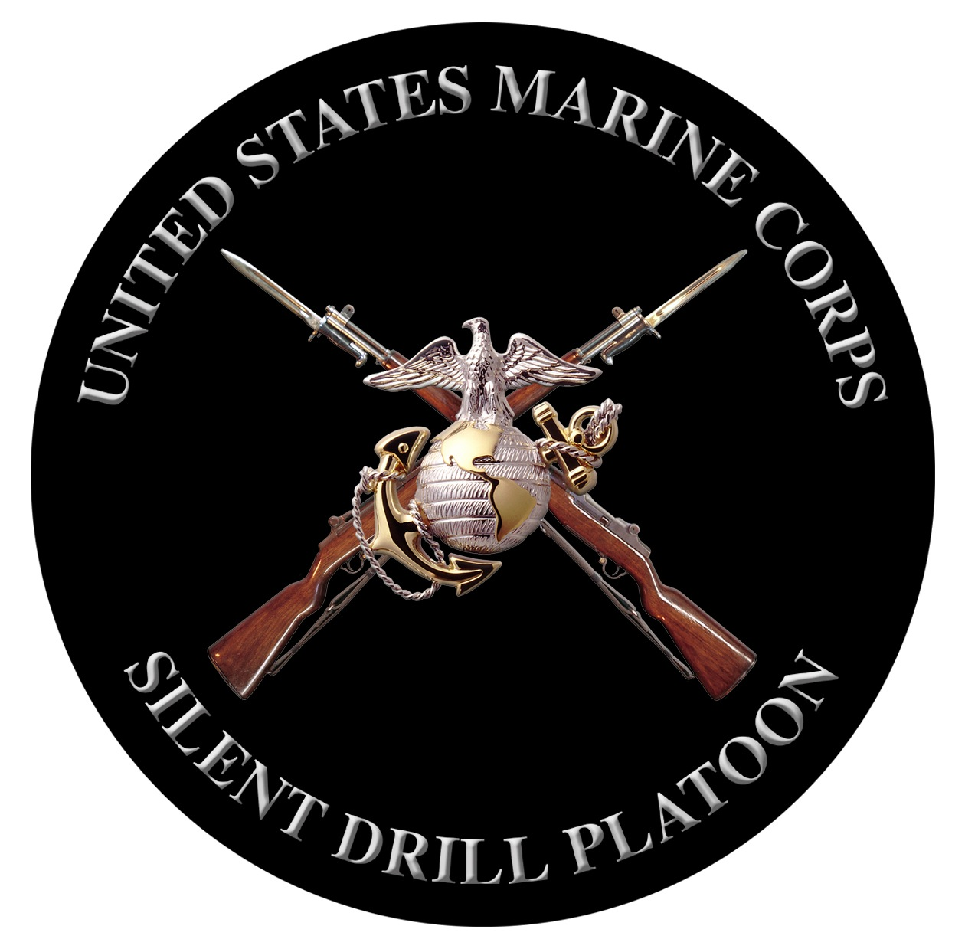

**Official Color Guard Logo**

**Official Silent Drill Platoon Logo**



**Official Logo**

**“The Commandant’s Own”**

**The United States Marine Drum & Bugle Corps**